**A Project Report On**

**FRONT END DESIGN FOR BALAJI FRUIT COMPANY**

**Submitted to**

**Edubridge Learning private limited, Mumbai**

**In partial fulfilment of the requirements for the award of**

**Course in**

**SOFTWARE TESTING**

**By**

**Miss. Kamal Suresh Dukare**

**(Centre-Thane, batch code-7670)**

**Under Guidance of**

**Mrs. Mohana Priya**

**(Centre Trainer of Software Testing)**

**Course of Software Testing**

**Edubridge Learning Private Limited, Mumbai**



**2022-2023**

**TABLE OF CONTENT**

**1.INRODUCTION**

### Objective

* 1. Scope

## HARDWARE AND SOFTWARE REQUIREMENTS

2.1 Hardware Requirement

2.2.Software Requirement

1. **SYSTEM DESIGN**

### 3.1Use Case Diagram

3.2Activity Diagram

3.3Class Diagram

* 1. ER Diagram

3.5Data Level Flow Diagram

1. **IMPLEMENTATION MODULE**

4.1Coding

4.2Screenshots

## SYSTEM TESTING

### 5.1Types of Testing

5.2Testing Methodology

### 5.3Equivalence class Partitioning

5.4Test Report

* + 1. 5.5Test cases
    2. 5.6Automation Testing code

1. **CONCLUSION**

1. **INTRODUCTION**

The BALAJI FRUIT COMPANY website has been developed to overwrite the problem prevailing in the practicing manual system the software is supported to illuminate and its some cases red is the heart shaped faces by the distance system moreover this system is designed for the particular need to the company to carry out operation in the smooth and effective manner.

The application is a research methods as possible to avoid error while entering the data it also provide error message while entering avoid data no formal knowledge is needed for the user to use this system does the by dissolute screw it is user friendly fruit selling website as described about can lead to error free security level and first management system user to concentrate on their other activity rather be concentrate on the Record Keeping does it with help organise it better utilise of resource.

**1.1 OBJECTIVE**

The main objective of the project on BALAJI fruit website is to manage the detail of fruit type category order customer it manage all the information about fruit customer order history customer fruit the project is totally built at administrative and only the administrator is guaranteed the access the purpose of the project is to build an application program to reduce the manual for managing the fruit type customer order history category it track all the detail about the category order customer

Functionality provided by BALAJI FRUIT COMPANY Website are as follows:

provide the searching facility based on various factors such as fault category order customer fruit selling website also manage the customer order history detail online for order details' customer care flute it track the information of type customer order history order ITC manage the information of type show the information of description of the fruit category to increase effectively of managing the fruit type it monitoring the information and transaction of water management information of fruit editing and updating recording

**1.2 Scope**

It may help collecting perfect management in detail in a very short time the collection will be a favourite simple and sensible it will help a person to know the management of POS air perfectly and so help it current all world related to fruit selling website it will be also reduce the cost of collecting the management and collection procedure will go on smoothly

**Our project business process automation that is we have tried to computerized various process of fruit selling website**

in computer system the person has to fill the various form and number of copy of the form can be easily generator at a time in computer system it is not necessary to create the manifest but we can directly print it which save our time

To assist app in computer in the effort spent on their respective working area utilise resources and effective manner by increasing their productivity through automation system generate type of information that can be used for various purpose it satisfy the user requirement be easily to understand by the user and operator be easy to operate have a good user interface be Expendables

1. **HARDWARE AND SOFTWARE REQUIREMENT**

In this chapter, we will discuss and analyze about the developing process of Library Management System including software requirement specification (SRS) and comparison between existing and proposed system. The functional and non functional requirements are included in SRS part to provide complete description and overview of system requirement before the developing process is carried out. Besides that, existing VS proposed provides a view of how the proposed system will be more efficient than the existing one.

### Requirement specification

Requirement specification describes the function and performance of the computer based system and constraints which govern its development. It can be a written document, a set of graphical models, a collection of Scenarios, or any combination of above.

#### FUNCTIONAL REQUIREMENT

* System must perform data pre-processing to remove unwanted data.
* Divided the dataset into training dataset and testing dataset.
* Find the correlation.
* Using classification model system predicts the news success and failure rating.

#### NON-FUNCTIONAL REQUIREMENT

* Extensibility: System should able to add feature and carry forward of customization at next major version up-grade.
* Privacy: Privacy should maintain throughout the system.
* User Friendliness: GUI should be user friendly.
* Responsive: System should give response to the request quickly.

#### 2.1 Software Requirements

* Operating System : Linux/ Windows

**Front End**

* HTML, CSS, JavaScript are utilized to implement the frontend.
* HTML: HTML stands for **Hyper Text Mark up language** is the standard mark up language for creating Web pages.
* CSS: CSS stands for **Cascading Style Sheets**. It Describes how HTML elements are to be displayed on screen, paper, or in other media.
* JavaScript: An object oriented programming language commonly used to create interactive effects within web browsers.

**Back End:** MYSQL

#### 2.2 Hardware Requirements

* Intel Processor
* Speed : 1.1GHZ
* Hard-Disk : 500GB
* Ram : 2GB

1. **SYSTEM DESIGN**

**3.1 Use case diagram:**

* + - * **Use Case:** A use case involves a sequence of interactions between the initiator and the system, possibly involving other actor. A use case diagram at its simplest is a representation of a user interaction with the system and depicting the specifications of a use case. A use case diagram can portray the different types of users of a system and the various ways that they interact with the system. This type of diagram is typically used in conjunction with the textual use case and will often be accompanied by other types of diagram as well.

Admin

User

**3.2 Activity diagram:**

* + - * **Activity Diagram:** Activity diagrams are graphical representations of work flows of step- wise activities and actions with support for choice, iteration and concurrency. In the UML activity diagrams are in-tended to model both computational and organizational processes (i.e. work flows). Activity diagrams show the overall flow of control. Activity diagrams are very similar to a flowchart because you can model a workflow from activity to activity.

**User**

Book product

search product

Add user Details

Select our Product

**3.3Class Diagram:**

A class diagram in the Unified Modeling Language (UML) is a type of static structure diagram that describes the structure of a system by showing the system classes, their attributes, operations (or methods), and the relationships among objects. The class diagram is the main building block of object oriented modeling Class diagrams can also be used for data modeling. The classes in a class diagram represent both the main Objects , interactions in the application and the classes to be programmed.

* + - * + Attribute
        + Operation
        + Relationship
        + Semantics.

|  |
| --- |
| Customer class |
| +User-id: Int  +User-name: string  +User-mobilel: string  +User-address: string |
| +add Customer ()  +edit Customer ()  +delete Customer ()  +search Customer () |

|  |
| --- |
| **User class** |
| +User-id: Int  +User-name: string  +User-email: string  +User-add: string |
| +add User()  +edit User()  +delete User()  +search User() |

|  |
| --- |
| Permission class |
| +User-id: Int  +User-name: string  +User-role: string  +User-module: string |
| +add Permission()  +edit Permission ()  +delete Permission ()  +search Permission () |

|  |
| --- |
| Category tag |
| +User-id: Int  +User-name: string  +User-description: string  +User-item-id: string |
| +add Category()  +edit Category ()  +delete Category ()  +search Category () |

|  |
| --- |
| Fruit tag |
| +User-id: Int  +User-name: string  +User-description: string  +User-type: string |
| +addUser()  +editUser()  +deleteUser()  +searchUser() |

**3.4 Data Flow Diagram:**

A data flow diagram (DFD) is a graphical representation of the data through an information system, modeling its process aspects. A DFD is often used as a preliminary step to create an overview of the system, which can later be elaborated. DFDs can also be used for the visualization of data processing (structured design).A DFD shows what kind of information will be input to and output from the system, where the data will come from and go to, and where the data will be stored. It does not show information about the timing of processes, or information about whether processes will operate in sequence or in parallel. Data flow diagram (DFD) is also called as Bubble Chart is a graphical technique, which is used to represent information flow, and transformers those are applied when data moves from input to output. DFD represents system requirements clearly and identify transformers those becomes

Testing fruit image

Fruit image

Pre-processing

Pre-processing

Feature extraction

Accuracy calculation

Train classifire

Feature extraction

Classification

**3.5 ENTITY DIAGRAM:**

User

Have

Have

Order

Product

1. **IMPLEMENTATION**

In BALAJI fruit company website project that have been used in developing the front end of the project are being discussed in this chapter.

FRONT END:

HTML, CSS, JAVASCRIPT, are utilized to implement the Frontend

[HTML](https://www.w3.org/html/) (the Hypertext Markup Language) and [CSS](https://www.w3.org/Style/CSS/) (Cascading Style Sheets) are two of the core technologies for building Web pages. HTML provides the *structure* of the page, CSS the (visual and aural) *layout,* for a variety of devices. Along with [graphics](https://www.w3.org/standards/webdesign/graphics) and [scripting](https://www.w3.org/standards/webdesign/script), HTML and CSS are the basis of building Web pages and Web Applications.

[CSS](https://www.w3.org/Style/CSS/) is the language for describing the presentation of Web pages, including colors, layout, and fonts. It allows one to adapt the presentation to different types of devices, such as large screens, small screens, or printers. CSS is independent of HTML and can be used with any XML-based markup language. The separation of HTML from CSS makes it easier to maintain sites, share style sheets across pages, and tailor pages to different environments. This is referred to as the *separation of structure (or: content) from* presentation.

[JavaScript](https://developer.mozilla.org/en-US/docs/Glossary/JavaScript) is a scripting language that enables you to create dynamically updating content, control multimedia, animate images, and pretty much everything else. (Okay, not everything, but it is amazing what you can achieve with a few lines of JavaScript code.)

In Fresh Online Grocery Ordering Website is an online web application for automating the process of ordering grocery products from suppliers and paying for them in advance. Therefore, there is no need for the suppliers to wait for a long time and pay in cash at the time of delivery. This system also helps farmers to sell their products through this system.

The current Grocery Ordering system is not much efficient and can lead to a major waste of time as the supplier needs to wait for a long period. The main purpose to design this Online Grocery Ordering application is to provide an environment where the users will be able to order products from a supplier and pay in advance.

**HTML Tags used in Project:**

1. Header:

The <header> tag in HTML is used to define the header for a document or a section as it contains the information related to the title and heading of the related content. The <header> element is intended to usually contain the section's heading

1. Anchor Tag:

<a>: The Anchor element. The <a> HTML element (or anchor element), with its HREF attribute, creates a hyperlink to web pages, files, email addresses, locations in the same page, or anything else a URL can address. Content within each <a> should indicate the link's destination.

1. Nav:

The <nav> HTML element represents a section of a page whose purpose is to provide navigation

Link either within the current document or to other documents. Common examples of navigation sections are menus, tables of contents, and indexes.

1. Div:

The <div> tag defines a division or a section in an HTML document. The <div> tag is used as a container for HTML elements - which is then styled with CSS or manipulated with JavaScript. The

<div> tag is easily styled by using the class or id attribute.

1. Form:

An **HTML form** is *a section of a document* which contains controls such as text fields, password fields, checkboxes, radio buttons, submit button, menus etc.

An HTML form facilitates the user to enter data that is to be sent to the server for processing such as name, email address, password, phone number, etc...

1. Span:

The <span> tag is an inline container used to mark up a part of a text, or a part of a document. The

<span> tag is easily styled by CSS or manipulated with JavaScript using the class or id attribute. The

<span> tag is much like the <div> element, but <div> is a block-level element and <span> is an inline element

1. Img:

The <img> tag creates a holding space for the referenced image. The <img> tag has two required attributes: src - Specifies the path to the image. alt - Specifies an alternate text for the image,

1. section

<section> tag defines the section of documents such as chapters, headers, footers or any other sections. The section tag divides the content into section and subsections

1. Heading Tags

<h1> tag is an HTML heading that's most commonly used to mark up a web page title. Most websites use CSS to make the H1 stand out on the page compared to less headings like H2, H3, etc

<h2> tag defines the second level heading in the HTML document. This tag is also commonly referred to as the <h2> element

<h3> tag defines the third level heading in the HTML document. This tag is also commonly referred to as the <h3> element

**CODING:**

<!DOCTYPE html>

<html>

<head>

<title>Balaji Fruit company</title>

<style>

body{

margin: 0;

}

.balaji

{

background-image: url('abc1.jpg');

padding: 0;

}

#top{

text-align:center;

font-size:46px;

}

#top1

{

text-align:center;

color:black;

font-size:21px;

}

div.scrollmenu {

background-color: #333;

overflow: auto;

white-space: nowrap;

text-align: center;

}

div.scrollmenu a {

display: inline-block;

color: white;

text-align: center;

padding: 20px;

text-decoration: none;

}

div.scrollmenu a:hover {

background-color: #777;

}

</style>

</head>

<body>

<div class="balaji">

<header>

<center> <h1 id="top">Balaji</h1>

<center><h1 id="top1">Fruit company</h1></center></center></header></div>

<div class="scrollmenu">

<a href="home.html">Home</a>

<a href="Our product.html">Our Product</a>

<a href="contact us.html">Contact</a>

<a href="about.html">About</a>

<a href="orders.html">Wholesale orders</a>

<a href="delivary.html">Delivary location</a>

</div>

<div class="right" style="background-color:;">

<marquee behavior="alternet" direction="left" >

<img src="image1.jpg" height="500px"; width="" >&nbsp; &nbsp; &nbsp;&nbsp; &nbsp;

<img src="image6.jpg" height="500px"; width="" >&nbsp; &nbsp; &nbsp;&nbsp; &nbsp;

<img src="image2.jpg" height="500px"; width="" >&nbsp; &nbsp; &nbsp;&nbsp; &nbsp;

<img src="image5.jpg" height="500px"; width="" >&nbsp; &nbsp; &nbsp;&nbsp; &nbsp;

<img src="image7.jpg" height="500px"; width="" >&nbsp; &nbsp; &nbsp;&nbsp; &nbsp;

<img src="image8.jpg" height="500px"; width="" >&nbsp; &nbsp; &nbsp;&nbsp; &nbsp;

<img src="image3.jpg" height="500px"; width="" >&nbsp; &nbsp; &nbsp;&nbsp; &nbsp;

<img src="image12.jpg" height="500px"; width="" >

marquee>

</body>

</html>

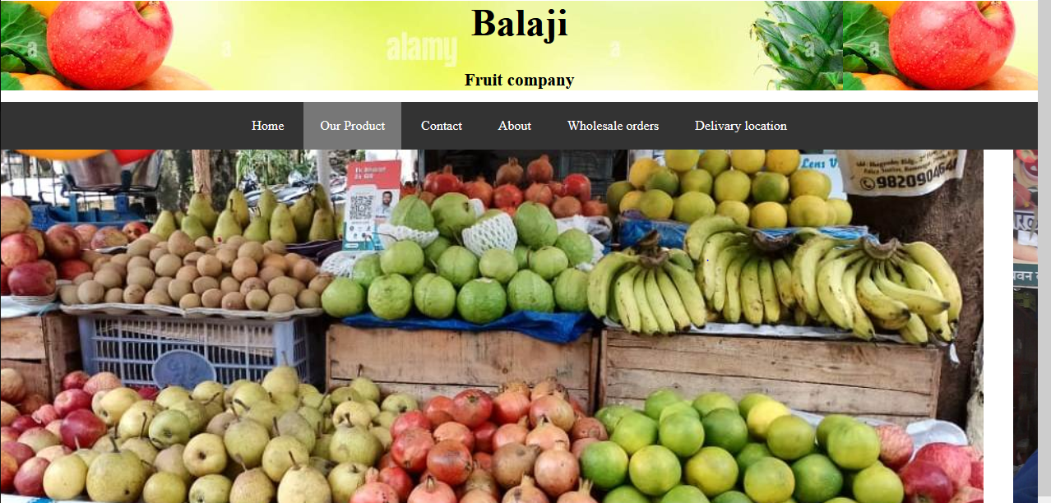

<!DOCTYPE html>

<html>

<head>

<title></title>

<link href="https://cdn.jsdelivr.net/npm/bootstrap@5.2.2/dist/css/bootstrap.min.css" rel="stylesheet" integrity="sha384-Zenh87qX5JnK2Jl0vWa8Ck2rdkQ2Bzep5IDxbcnCeuOxjzrPF/et3URy9Bv1WTRi" crossorigin="anonymous">

<style>

body{

margin: 0;

}

.balaji

{

background-image: url('abc1.jpg');

padding: 0;

}

#top{

text-align:center;

font-size:46px;

}

#top1{

text-align:center;

color:black;

font-size:21px;

}

div.scrollmenu {

background-color: #333;

overflow: auto;

white-space: nowrap;

text-align: center;

}

div.scrollmenu a {

display: inline-block;

color: white;

text-align: center;

padding: 20px;

text-decoration: none;

}

div.scrollmenu a:hover {

background-color: #777;

}

</style>

</head>

<body>

<div class="balaji">

<header>

<center> <h1 id="top">Balaji</h1>

<center><h1 id="top1">Fruit company</h1></center></center></header></div>

<div class="scrollmenu">

<a href="home.html">Home</a>

<a href="Our product.html">Our Product</a>

<a href="contact us.html">Contact</a>

<a href="about.html">About</a>

<a href="orders.html">Wholesale orders</a>

<a href="delivary.html">Delivary location</a>

</div>

<div class="container" style="background-color:gainsboro ;">

<div class="row">

<div class="col-xl-6 col-lg-6 col-md-6" style="color:navy"><div>

<h2><b>Apple</b></h2><br>

<img src="apple.jpg" height="500"; width="500" ; ></div></div>

<div class="col-xl-6 col-lg-6 col-md-6" style="color: green"><div>

<h2><b>Information</b></h2><br>

<h4><p>There are 10 variety of apple in our shop.</p>

<p>1.Braeburn,2.Fuji,3.Gala,4.Red Delicious,5.Honeycrisp,6.Jonathan,7.jonagold,8.pacific rose,9.Wealthy,10.cox</p>

<p>Quality Available: A Grade</p>

<p>Color: Red</p>

<p>Packaging Size: 15 Kg</p>

<p>Business Type: Wholesaler and Retailer</p>

<p>It is Organic: Yes</p>

<p>Minimum and Maximum Price:70 to 180 par kg.</p>

</h4></div>

</div>

<div class="col-xl-6 col-lg-6 col-md-6"><div>

<h2><b>Orange</b></h2><br>

<img src="Orange12.jpg" height="500px"; width="500px" ; >

</div></div>

<div class="col-xl-6 col-lg-6 col-md-6" style="color: green">

<div><h2><b>Information</b></h2><br>

<h4><p>There are 2 type of orange available in our shop.</p>

<p>Color: Green and Yellow.</p>

<p>Quality Available: A Grade</p>

<p>Vitamin: vitamin c</p>

<p>Minimum and Maximum Price:70 to 150 par kg.</p>

<p>Business Type: Wholesaler and Retailer</p>

<p>It is Organic: Yes</p></h4></div></div>

<div class="col-xl-6 col-lg-6 col-md-6"><div>

<h2><b>Watermelon</b></h2><br>

<img src="watermelon.jpg" height="500px"; width="500px" ;></div>

</div>

<div class="col-xl-6 col-lg-6 col-md-6" style="color: green">

<div><h2><b>Information</b></h2><br>

<h4><p>The sweet Watermeon available in our shop.</p>

<p>Minimum and Maximum Price:30 to 50 per kg</p>

<p>Quality Available: A Grade</p>

<p>Business Type: Wholesaler and Retailer</p>

<p>It is Organic: Yes</p>

<p>Packaging Type:Plastic bag</p>

<p>Country: made in India</p></h4>

</div>

</div>

<div class="col-xl-6 col-lg-6 col-md-6"><div>

<h2><b>Mango</b></h2><br>

<img src="mango.jpg" height="500px"; width="500px" ; ></div>

</div><div class="col-xl-6 col-lg-6 col-md-6" style="color: green">

<div><h2><b>Information</b></h2><br>

<h4><p>There are many type of Variety available in our shop.</p>

<p>1.Alphonso 2.kesar 3.totapuri 4.dasheri 5.Raw rajapuri </p>

<p>Minimum and Maximum Price:100 to 500 per dozen</p>

<p>Quality Available: A Grade</p>

<p>Business Type: Wholesaler and Retailer</p>

<p>It is Organic: Yes</p>

<p>Packaging Type:Plastic bag</p>

<p>Country: made in India</p>

<p>color: Yellow</p>

</h4>

</div></div>

<div class="col-xl-6 col-lg-6 col-md-6"><div>

<h2><b>Banana</b><br>

<img src="b1.jpg" height="500px"; width="500px" ; ></div>

</div><div class="col-xl-6 col-lg-6 col-md-6" style="color: green"><div>

<h2><b>Information</b></h2><br>

<h4><p>There are 3 type of banana in our shop.</p>

<p>1.Cavendish banana 2.Lady finger banana 3.Latundan banana </p>

<p>Minimum and Maximum Price:30 to 120 per Dozen</p>

<p>Quality Available: A Grade</p>

<p>Business Type: Wholesaler and Retailer</p>

<p>It is Organic: Yes</p>

<p>Color Yellow</p>

<p>Country: made in India</p>

<p>Feature :Easily digestible</p></h4>

</div>

</div>

<div class="col-xl-6 col-lg-6 col-md-6">

<div>

<h2><b>Pomegranate</b></h2><br>

<img src="pomegranate1.jpg" height="500px"; width="500px" ; >

</div>

</div>

<div class="col-xl-6 col-lg-6 col-md-6" style="color: green">

<div>

<h2><b>Information</b></h2><br>

<h4><p>There are 5 type of pomegranate in our shop.</p>

<p>1.Angel red 2.Golden Globe 3.kara Gul 4.Ambrosia 5.Sweet pomegranate </p>

<p>Minimum and Maximum Price:100 to 180 per kg</p>

<p>Quality Available: A Grade</p>

<p>Business Type: Wholesaler and Retailer</p>

<p>It is Organic: Yes</p>

<p>Packaging Type:carton</p>

<p>Country: made in India</p>

<p>Vitamin: c</p>

<p>protein:1.7gm</p>

<p>Self life:15 days</p>

</h4> </div>

</div>

<div class="col-xl-6 col-lg-6 col-md-6">

<div>

<h2><b>Papaya</b></h2><br>

<img src="Papaya.jpg" height="500px"; width="500px" ; >

</div>

</div>

<div class="col-xl-4 col-lg-4 col-md-4" style="color: green">

<div>

<h2><b>Information</b></h2><br>

<h4><p>There are 4 type of Papaya in our shop.</p>

<p>1.Maxican red 2.Hawaiian sunrise 3.Tainung 4.Royal star</p>

<p>Minimum and Maximum Price:40 to 60 per kg</p>

<p>Quality Available: A Grade</p>

<p>Business Type: Wholesaler and Retailer</p>

<p>It is Organic: Yes</p>

<p>Color:Yellow-orange </p>

<p>Country: made in India</p></h4>

</div>

</div>

<div class="col-xl-6 col-lg-6 col-md-6">

<div>

<h2><b>Kiwi</b></h2><br>

<img src="Kiwi.jpg" height="500px"; width="500px" ; >

</div></div>

<div class="col-xl-6 col-lg-6 col-md-6" style="color: green">

<div>

<h2><b>Information</b></h2><br>

<h4><p>There are best kiwi available in our shop.</p>

<p>Self life:2 month</p>

<p>Minimum and Maximum Price:90 to 120 per packet</p>

<p>Quality Available: A Grade</p>

<p>Business Type: Wholesaler and Retailer</p>

<p>It is Organic: Yes</p>

<p>Packaging Type:carton</p>

<p>Country: made in India</p></h4>

</div>

</div>

<div class="col-xl-6 col-lg-6 col-md-6">

<div>

<h2><b>PineApple</b></h2><br>

<img src="Pineapple.jpg" height="500"; width="500" ; >

</div>

</div>

<div class="col-xl-6 col-lg-6 col-md-6" style="color: green">

<div>

<h2><b>Information</b></h2><br>

<h4><p>Minimum and Maximum Price:90 to 120 per peace</p>

<p>Quality Available: A Grade</p>

<p>Business Type: Wholesaler and Retailer</p>

<p>It is Organic: Yes</p>

<p>Packaging Type:Plastic bag</p>

<p>Usage:Human consumption</p>

<p>Country: made in India</p>

<p>Vitamin: c</p>

<p>Protein: 0.54 gm</p>

</h4>

</div>

</div>

<div class="col-xl-6 col-lg-6 col-md-6">

<div>

<h2><b>Plum</b></h2><br>

<img src="Plum.jpg" height="500"; width="500" ; >

</div>

</div>

<div class="col-xl-6 col-lg-6 col-md-6" style="color: green">

<div>

<h2><b>Information</b></h2><br>

<h4>

<p>Minimum and Maximum Price:180 to 200 per kg</p>

<p>Quality Available: A Grade</p>

<p>Business Type: Wholesaler and Retailer</p>

<p>It is Organic: Yes</p>

<p>Packaging Type:Packet</p>

<p>Country: made in India</p>

<p>Size:2 to 7cm in dimeter</p>l

<p>Color: blue purple</p>

</h4>

</div>

</div>

<div class="col-xl-6 col-lg-6 col-md-6">

<div>

<h2><b>Guava</b></h2><br>

<img src="Guava.jpg" height="500"; width="500" ;>

</div>

</div>

<div class="col-xl-6 col-lg-6 col-md-6" style="color: green">

<div>

<h2><b>Information</b></h2><br>

<h4> <p>There are 3 type of Guava in our shop .</p>

<p>1.Apple guava 2.maxican cream 3.Ruby supreme guava</p>

<p>Minimum and Maximum Price:40 to 100 per kg</p>

<p>Quality Available: A Grade</p>

<p>Business Type: Wholesaler and Retailer</p>

<p>It is Organic: Yes</p>

<p>Packaging Type:gunny bag</p>

<p>Country: made in India</p>

<p>Color:green, red</p>

</h4>

</div>

</div>

<div class="col-xl-6 col-lg-6 col-md-6">

<div>

<h2><b>Sapodilla</b></h2><br>

<img src="Sapodilla.jpg" height="500px"; width="500px" ; >

</div></div>

<div class="col-xl-6 col-lg-6 col-md-6" style="color: green">

<div>

<h2><b>Information</b></h2><br>

<h4><p>Minimum and Maximum Price:80 to 120 per kg</p>

<p>Quality Available: A Grade</p>

<p>Business Type: Wholesaler and Retailer</p>

<p>It is Organic: Yes</p>

<p>Variety: fresh Sapota</p>

<p>Maturity: 100% natural</p>

<p>Country: made in India</p>

<p>Speciality:No artificial flavor</p>

<p>feature:Mouth watering treat</p>

</h4>

</div>

</div>

<div class="col-xl-6 col-lg-6 col-md-6">

<div>

<h2><b>Pear</b></h2><br>

<img src="pear.jpg" height="500px"; width="500px" ; >

</div></div>

<div class="col-xl-6 col-lg-6 col-md-6" style="color: green">

<div>

<h2><b>Information</b></h2><br>

<h4><p>There are 3 type of pear in our shop.</p>

<p>1.Bartlett 2.comice 3.Anjou</p>

<p>Minimum and Maximum Price:30 to 50 per kg</p>

<p>Quality Available: A Grade</p>

<p>Business Type: Wholesaler and Retailer</p>

<p>It is Organic: Yes</p>

<p>Packaging Type:carton</p>

<p>Country: made in India</p>

<p>Variety:fresh fear</p>

</h4>

</div>

</div>

<div class="col-xl-6 col-lg-6 col-md-6">

<div>

<h2><b>Dragon Fruit</b></h2><br>

<img src="Dragon.jpg" height="500px"; width="500px" ; >

</div>

</div>

<div class="col-xl-6 col-lg-6 col-md-6" style="color: green">

<div>

<h2><b>Information</b></h2><br>

<h4><p>Minimum and Maximum Price:30 to 50 per kg</p>

<p>Quality Available: A Grade</p>

<p>Business Type: Wholesaler and Retailer</p>

<p>It is Organic: Yes</p>

<p>Packaging Type:carton</p>

<p>Country: made in India</p>

<p>Variety:fresh fear</p>

<p>Color: red</p></h4>

</div></div>

<div class="col-xl-6 col-lg-6 col-md-6" >

<div>

<h2><b>Custard apple</b></h2><br>

<img src="Custard.jpeg" height="500"; width="500" ; >

</div>

</div>

<div class="col-xl-6 col-lg-6 col-md-6" style="color: green">

<div>

<h2><b>Information</b></h2><br>

<h4><p>Minimum and Maximum Price:80 to 150 per kg</p>

<p>Quality Available: A Grade</p>

<p>Business Type: Wholesaler and Retailer</p>

<p>It is Organic: Yes</p>

<p>Packaging Type:carton</p>

<p>Country: made in India</p>

<p>Variety:Kashmiri/NMKI</p></h4>

</div>

</div>

<div class="col-xl-6 col-lg-6 col-md-6">

<div>

<h2><b>Tamarind</b></h2><br>

<img src="Tamarind.jpg" height="500px"; width="500px" ; >

</div>

</div>

<div class="col-xl-6 col-lg-6 col-md-6" style="color: green">

<div>

<h2><b>Information</b></h2><br>

<h4><p>Minimum and Maximum Price:120 Rs per packet</p>

<p>Quality Available: A Grade</p>

<p>Business Type: Wholesaler and Retailer</p>

<p>It is Organic: Yes</p>

<p>Packaging Type:packet</p>

<p>Country: made in India</p>

<p>Variety:fresh</p>

<p>Self life: 2 to 4 month</p></h4>

</div>

</div>

</div>

</div>

</body>

</html>

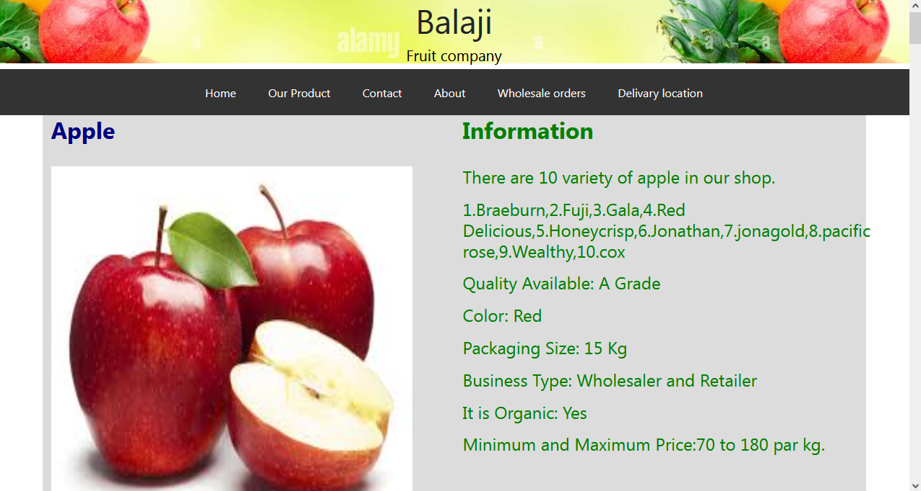

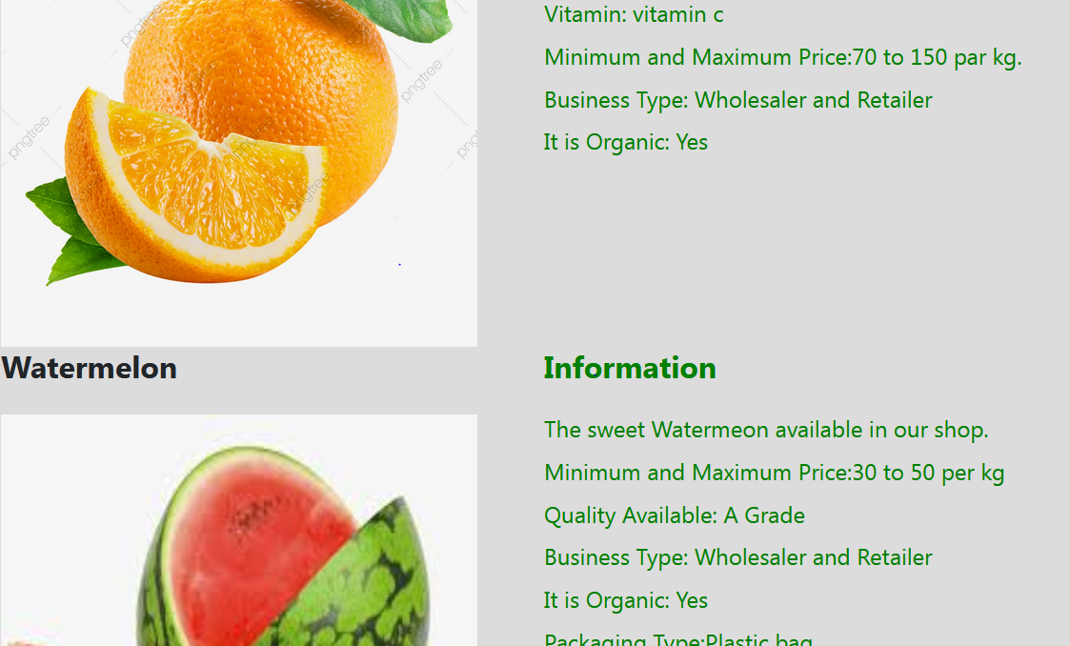

<!DOCTYPE html>

<html>

<head>

<title>contact us</title>

<title></title>

<meta charset="utf-8">

<meta name="viewport" content="width=device-width, initial-scale=1">

<link rel="stylesheet" type="text/css" href="assets/bootstrap.css">

<script type="text/javascript" src="assets/jquery.min.js"></script>

<script type="text/javascript"src="assets/bootstrap.js"></script>

<link href="https://cdn.jsdelivr.net/npm/bootstrap@5.2.2/dist/css/bootstrap.min.css" rel="stylesheet" integrity="sha384-Zenh87qX5JnK2Jl0vWa8Ck2rdkQ2Bzep5IDxbcnCeuOxjzrPF/et3URy9Bv1WTRi" crossorigin="anonymous">

<style type="">

body{

margin: 0;

}

.balaji

{

background-image: url('abc1.jpg');

padding: 0;

}

#top{

text-align:center;

font-size:46px;

}

#top1{

text-align:center;

color:black;

font-size:21px;

}

div.scrollmenu {

background-color: #333;

overflow: auto;

white-space: nowrap;

text-align: center;

}

div.scrollmenu a {

display: inline-block;

color: white;

text-align: center;

padding: 20px;

text-decoration: none;

}

div.scrollmenu a:hover {

background-color: #777;

}

.h1

{

color: green;

text-shadow: 54%;

}

</style>

</head>

<body><div class="balaji">

<header>

<center> <h1 id="top">Balaji</h1>

<center><h1 id="top1">Fruit company</h1></center></center></header></div>

<div class="scrollmenu">

<a href="home.html">Home</a>

<a href="Our product.html">Our Product</a>

<a href="contact us.html">Contact</a>

<a href="about.html">About</a>

<a href="orders.html">Wholesale orders</a>

<a href="delivary.html">Delivary location</a>

</div>

<div class="container">

<div class="row">

<div class="col-xl-8 col-lg-8 col-md-8" style="color: pink; background-color: green;">

<div>

<center><h1><b>Contact Us</b></h1></center>

<h3>Send Us An Email</h3>

<p>Have a question or two to ask? Feel free to give us a call or just fill out the contact us form below to send us an email.</p>

<p>Please try to be as detailed as possible so we can provide you with the proper information when replying. </p>

<center>

<form >

<label for="fname">First name:</label><br>

<input type="text" id="fname" name="fname"><br><br>

<label for="lname">Last name:</label><br>

<input type="text" id="lname" name="lname"><br><br>

<label for="email">Enter your email:</label><br>

<input type="email" id="email" name="email"><br><br>

<label for="Number">Enter your Number:</label><br>

<input type="Number" id="value" name="Number"><br><br>

<label for="company name">Company:</label><br>

<textarea id="w3review" name="w3review" rows="4" cols="50"></textarea><br><br>

<label for="email">Your Message:</label><br>

<textarea id="w3review" name="w3review" rows="15" cols="50"></textarea><br><br>

<input type="submit" value="Send Email">

</form></center>

</div>

</div>

<div class="col-xl-4 col-lg-4 col-md-4" style="color: ;">

<div>

<h2 style="color: green;">Balaji Fruit Company</h2>

<h6>Supplier of quality Fruit Service Companies</h6>

<h2 style="color: green;">Address:<h2><h6>shop no.1,<br>B wing,<br>shanti co. operative housing society<br> lodha heaven,<br>nilje,dombivili east Dombivli kalyan,<br>thane,421204<h6>

<h2 style="color: solid black;">Contact:</h2>

<h6>Phone: 9892800566</h6>

<h6>Phone:8450989852</h6>

<h2 style="color: green;">Office Hours:</h2>

<h6>Mon-Sun: 8am -9pm </h6>

</div></div></div></div>

</body>

</html>

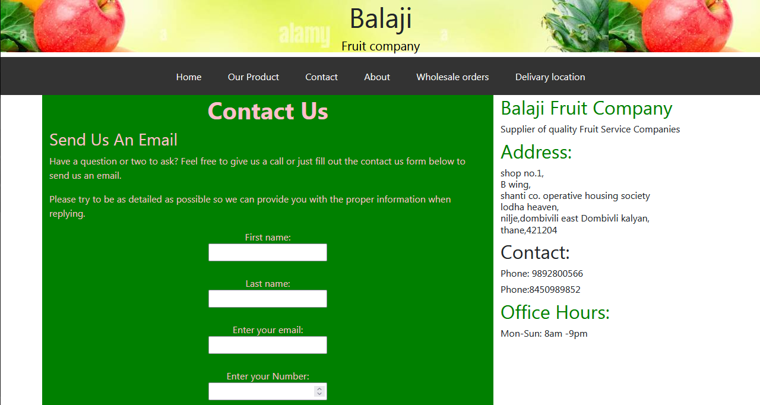

<html>

<head>

<title></title>

<link href="https://cdn.jsdelivr.net/npm/bootstrap@5.2.2/dist/css/bootstrap.min.css" rel="stylesheet" integrity="sha384-Zenh87qX5JnK2Jl0vWa8Ck2rdkQ2Bzep5IDxbcnCeuOxjzrPF/et3URy9Bv1WTRi" crossorigin="anonymous">

<meta name="viewport" content="width=device-width, initial-scale=1">

<style>

body{

margin: 0;

}

.balaji

{

background-image: url('abc1.jpg');

padding: 0;

}

#top{

text-align:center;

font-size:46px;

}

#top1{

text-align:center;

color:black;

font-size:21px;

}

div.scrollmenu {

background-color: #333;

overflow: auto;

white-space: nowrap;

text-align: center;

}

div.scrollmenu a {

display: inline-block;

color: white;

text-align: center;

padding: 20px;

text-decoration: none;

}

div.scrollmenu a:hover {

background-color: #777;

}

{box-sizing: border-box}

body {font-family: Verdana, sans-serif; margin:0}

.mySlides {display: none}

img {vertical-align: middle;}

/* Slideshow container */

.slideshow-container {

max-width: 1000px;

position: relative;

margin: auto;

}

.container {

font-family: Arial;

margin: 0;

}

* {

box-sizing: border-box;

}

img {

vertical-align: middle;

}

/* Position the image container (needed to position the left and right arrows) */

.container {

position: relative;

}

/* Hide the images by default */

.mySlides {

display: none;

}

/* Add a pointer when hovering over the thumbnail images */

.cursor {

cursor: pointer;

}

/* Next & previous buttons */

.prev,

.next {

cursor: pointer;

position: absolute;

top: 40%;

width: auto;

padding: 16px;

margin-top: -50px;

color: white;

font-weight: bold;

font-size: 20px;

border-radius: 0 3px 3px 0;

user-select: none;

-webkit-user-select: none;

}

/* Position the "next button" to the right */

.next {

right: 0;

border-radius: 3px 0 0 3px;

}

/* On hover, add a black background color with a little bit see-through */

.prev:hover,

.next:hover {

background-color: rgba(0, 0, 0, 0.8);

}

/* Number text (1/3 etc) */

.numbertext {

color: #f2f2f2;

font-size: 12px;

padding: 8px 12px;

position: absolute;

top: 0;

}

/* Container for image text */

.caption-container {

text-align: center;

background-color: #222;

padding: 2px 16px;

color: white;

}

.row:after {

content: "";

display: table;

clear: both;

}

/* Six columns side by side */

.column {

float: left;

width: 16.66%;

}

/* Add a transparency effect for thumnbail images */

.demo {

opacity: 0.6;

}

.active,

.demo:hover {

opacity: 1;

}

</style>

</head>

<body>

<div class="balaji">

<header>

<center> <h1 id="top">Balaji</h1>

<center><h1 id="top1">Fruit company</h1></center></center></header></div>

<div class="scrollmenu">

<a href="home.html">Home</a>

<a href="Our product.html">Our Product</a>

<a href="contact us.html">Contact</a>

<a href="about.html">About</a>

<a href="orders.html">Wholesale orders</a>

<a href="delivary.html">Delivary location</a>

</div>

<h2 style="text-align:center">Slideshow Gallery</h2>

<center><div class="container">

<div class="mySlides">

<div class="numbertext">1 / 6</div>

<img src="kt1.jpg" style="width: 100%; height: 70%">

</div>

<div class="mySlides">

<div class="numbertext">2 / 6</div>

<img src="image2.jpg" style="width: 100%; height: 70%">

</div>

<div class="mySlides">

<div class="numbertext">3 / 6</div>

<img src="kt2.jpg" style="width: 100%; height: 70%">

</div>

<div class="mySlides">

<div class="numbertext">4 / 6</div>

<img src="image12.jpg" style="width: 100%; height: 70%">

</div>

<div class="mySlides">

<div class="numbertext">5 / 6</div>

<img src="image13.jpg" style="width: 100%; height: 70%">

</div>

<div class="mySlides">

<div class="numbertext">6 / 6</div>

<img src="image14.jpg" style="width: 100%; height: 70%">

</div>

<a class="prev" onclick="plusSlides(-1)">❮</a>

<a class="next" onclick="plusSlides(1)">❯</a>

<div class="caption-container">

<p id="caption"></p>

</div>

<!--

<div class="row">

<div class="column">

<img class="demo cursor" src="image6.jpg" style="width:100%" onclick="currentSlide(1)" alt="The Woods">

</div>

<div class="column">

<img class="demo cursor" src="simage5.jpg" style="width:100%" onclick="currentSlide(2)" alt="Cinque Terre">

</div>

<div class="column">

<img class="demo cursor" src="image4.jpg" style="width:100%" onclick="currentSlide(3)" alt="Mountains and fjords">

</div>

<div class="column">

<img class="demo cursor" src="image3.jpg" style="width:100%" onclick="currentSlide(4)" alt="Northern Lights">

</div>

<div class="column">

<img class="demo cursor" src="image2.jpg" style="width:100%" onclick="currentSlide(5)" alt="Nature and sunrise">

</div>

<div class="column">

<img class="demo cursor" src="image1.jpg" style="width:100%" onclick="currentSlide(6)" alt="Snowy Mountains">

</div>

</div>-->

</div>

<script>

let slideIndex = 1;

showSlides(slideIndex);

function plusSlides(n) {

showSlides(slideIndex += n);

}

function currentSlide(n) {

showSlides(slideIndex = n);

}

function showSlides(n) {

let i;

let slides = document.getElementsByClassName("mySlides");

let dots = document.getElementsByClassName("demo");

let captionText = document.getElementById("caption");

if (n > slides.length) {slideIndex = 1}

if (n < 1) {slideIndex = slides.length}

for (i = 0; i < slides.length; i++) {

slides[i].style.display = "none";

}

for (i = 0; i < dots.length; i++) {

dots[i].className = dots[i].className.replace(" active", "");

}

slides[slideIndex-1].style.display = "block";

dots[slideIndex-1].className += " active";

captionText.innerHTML = dots[slideIndex-1].alt;

}

</script>

<div> <h1 style="color: darkgreen">About Balaji Fruit Company</h1>

<h6>Three generations of value, service, and quality-that's Balaji Fruit Company. Established by the Balaji Fruit company in 1952, our long history of excellence has earned us repute as a leading produce supplier for Mumbai in Big company as like Reliance. Today, we're stronger than ever before. </h6>

</div>

<div class="container" style=" ;">

<div class="row">

<div class="col-xl-3 col-lg-3 col-md-3" style="">

<div>

<img src="kt.jpg" height="280px"; width="280px" ; >

</div>

</div>

<div class="col-xl-9 col-lg-9 col-md-9" style="">

<div>

<h3 style="color: red"><b>Dedicated to Our Family of Customers </b></h3>

<h6>

<p> As a Balaji customer, you'll never be "just a number." After 86+ years in the business, we've mastered the unique ability to maintain close working relationships with our customers while building an expansive line of produce and dairy products.</p>

<p>

Whether you're a corner market or big chain grocer, our staff gets to

know you and your business needs so that we can make every experience with us

a positive one. Being a smaller, family-owned company allows Balaji to

provide a level of flexibility and personalized service not found with other

suppliers. If there's a product you need that we don't have, we'll

find it for you. Have a special delivery request? Just give us a call!

</p>

</h6>

</div>

</div></div></div><br><br>

<div class="container" style=" ;">

<div class="row">

<div class="col-xl-3 col-lg-3 col-md-3" style="">

<div>

<img src="fruit.jpg" height="280px"; width="280px" ; >

</div>

</div>

<div class="col-xl-9 col-lg-9 col-md-9" style="">

<div>

<h3 style="color: red"><b>Looking to the Future</b></h3>

<h6>

<p>Times are changing, and Balaji Fruit Company is excited to evolve right along with our customers' needs. Our company will continue to invest in the latest technologies and equipment in order to provide retail and dining establishments with the quality and service they need to keep their business moving forward. </p>

</h6>

<h4><b>Discover the benefits of partnering with Balaji for your produce, dairy, and specialty item needs. Contact us today.</b></h4>

</div>

</div></div></div>

</body>

</html>

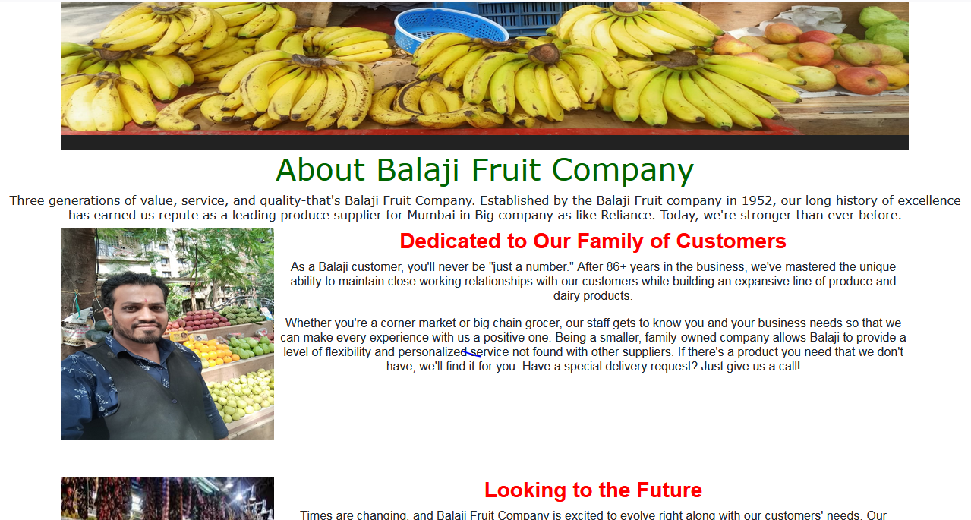

<!DOCTYPE html>

<html>

<head>

<title></title>

<link href="https://cdn.jsdelivr.net/npm/bootstrap@5.2.2/dist/css/bootstrap.min.css" rel="stylesheet" integrity="sha384-Zenh87qX5JnK2Jl0vWa8Ck2rdkQ2Bzep5IDxbcnCeuOxjzrPF/et3URy9Bv1WTRi" crossorigin="anonymous">

<style>

body{

margin: 0;

}

.balaji

{

background-image: url('abc1.jpg');

padding: 0;

}

#top{

text-align:center;

font-size:46px;

}

#top1{

text-align:center;

color:black;

font-size:21px;

}

div.scrollmenu {

background-color: #333;

overflow: auto;

white-space: nowrap;

text-align: center;

}

div.scrollmenu a {

display: inline-block;

color: white;

text-align: center;

padding: 20px;

text-decoration: none;

}

div.scrollmenu a:hover {

background-color: #777;

}

</style>

</head>

<body>

<div class="balaji">

<header>

<center> <h1 id="top">Balaji</h1>

<center><h1 id="top1">Fruit company</h1></center></center></header></div>

<div class="scrollmenu">

<a href="home.html">Home</a>

<a href="Our product.html">Our Product</a>

<a href="contact us.html">Contact</a>

<a href="about.html">About</a>

<a href="orders.html">Wholesale orders</a>

<a href="delivary.html">Delivary location</a>

</div>

<center>

<div style="color: green";>

<h3><b>Sign in</b></h3>

<form style="background-color: pink">

<p>Please fill out the following information.</p>

<p>An email with further instructions will be sent to you after review from our sales team.</p>

<label for="fname">First name:</label>

<input type="text" id="fname" name="fname"><br><br>

<label for="lname">Last name:</label>

<input type="text" id="lname" name="lname"><br><br>

<label for="email">Email:</label>

<input type="email" id="email" name="email"><br><br>

<label for="Number">Phone:</label>

<input type="Number" id="value" name="Number"><br><br>

<label for="fname">Fax:</label>

<input type="text" id="fname" name="fname"><br><br>

<label for="lname">Address:</label>

<input type="text" id="lname" name="lname"><br><br>

<label for="fname">City:</label>

<input type="text" id="fname" name="fname"><br><br>

<label for="lname">State:</label>

<input type="text" id="lname" name="lname"><br><br>

<label for="email">Zip:</label>

<input type="text" id="lname" name="lname"><br><br>

<label for="company name">Company:</label><br>

<textarea id="w3review" name="w3review" rows="4" cols="50"></textarea><br><br>

<input type="submit" value="Send Email">

<input type="submit" value="Cancel">

</form>

</div></center>iiiiiiiiiiiiiiiiiiiiihbhb/html>

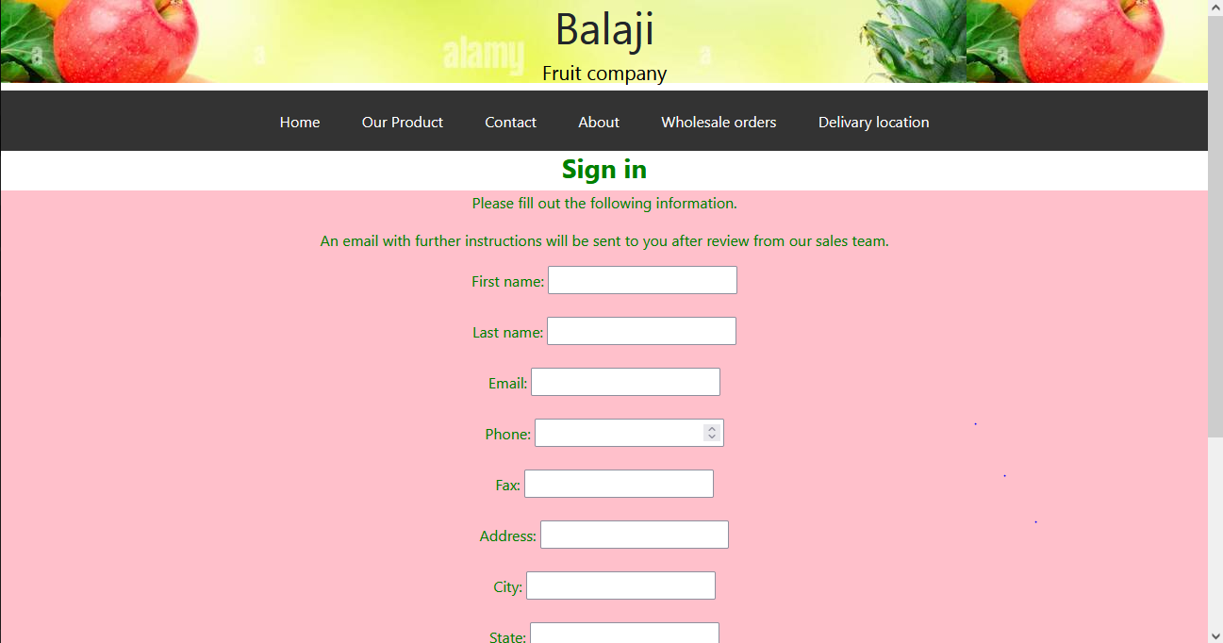

<!DOCTYPE html>

<html>

<head>

<title>Dilivary product</title>

<link href="https://cdn.jsdelivr.net/npm/bootstrap@5.2.2/dist/css/bootstrap.min.css" rel="stylesheet" integrity="sha384-Zenh87qX5JnK2Jl0vWa8Ck2rdkQ2Bzep5IDxbcnCeuOxjzrPF/et3URy9Bv1WTRi" crossorigin="anonymous">

<style>

body{

margin: 0;

}

.balaji

{

background-image: url('abc1.jpg');

padding: 0;

}#top{

text-align:center;

font-size:46px;

}

#top1{

text-align:center;

color:black;

font-size:21px;

}

div.scrollmenu {

background-color: #333;

overflow: auto;

white-space: nowrap;

text-align: center;

}

div.scrollmenu a {

display: inline-block;

color: white;

text-align: center;

padding: 20px;

text-decoration: none;

}

div.scrollmenu a:hover {

background-color: #777;

}

</style>

</head>

<body>

<div class="balaji">

<header>

<center> <h1 id="top">Balaji</h1>

<center><h1 id="top1">Fruit company</h1></center></center></header></div>

<div class="scrollmenu">

<a href="home.html">Home</a>

<a href="Our product.html">Our Product</a>

<a href="contact us.html">Contact</a>

<a href="about.html">About</a>

<a href="#orders.html">Wholesale orders</a>

<a href="#delivary.html">Delivary location</a>

</div>

<center><h1>Delivery product</h1></center><br><br>

<div class="container">

<div class="row">

<div class="col-xl-4 col-lg-4 col-md-4" style="">

<div>

<h5><b>Reliance</b></h5>

</div>

</div>

<div class="col-xl-4 col-lg-4 col-md-4" style="">

<div>

<h5><b>Mahidra and Mahidra</b></h5>

</div>

</div>

<div class="col-xl-4 col-lg-4 col-md-4" style="">

<div>

<h5><b>Bansara syntex </b></h5></div></div>

<div class="col-xl-4 col-lg-4 col-md-4" style="">

<div>

<h5><b>Ajit Mehta</b></h5>

</div>

</div>

<div class="col-xl-4 col-lg-4 col-md-4" style="">

<div>

<h5><b>Tanna Export</b></h5>

</div>

</div>

<div class="col-xl-4 col-lg-4 col-md-4" style="">

<div>

<h5><b>Damani shipping </b></h5>

</div>

</div>

<div class="col-xl-4 col-lg-4 col-md-4" style="">

<div>

<h5><b>jamunadas madhavji</b></h5>

</div>

</div>

<div class="col-xl-4 col-lg-4 col-md-4" style="">

<div>

<h5><b>Danvantari Hospital</b></h5></div>

</div>

<div class="col-xl-4 col-lg-4 col-md-4" style="">

<div>

<h5><b>TCRC</b></h5>

</div>

</div>

<div class="col-xl-4 col-lg-4 col-md-4" style="">

<div>

<h5><b>SRP</b></h5>

</div>

</div>

<div class="col-xl-4 col-lg-4 col-md-4" style="">

<div>

<h5><b>Kemax india</b></h5></div></div>

</body>

</html>

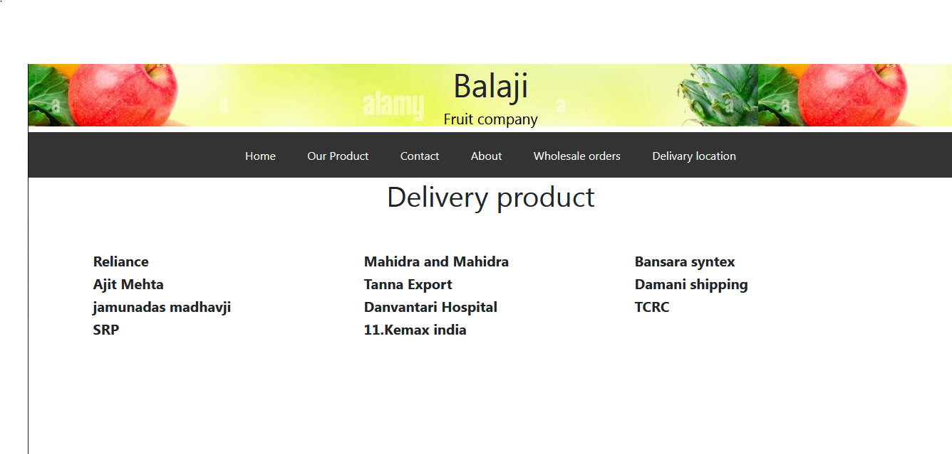

**Database connectivity:**

<?php

$server = "localhost";

$username = "root";

$password = "";

$dbname = "login form";

$con = mysqli_connect($server, $username, $password, $dbname); if(!$con)

{

echo "not connected";

}

$username = $_POST['username'];

$password = $_POST['password'];

$sql = "INSERT INTO `login`(`username`, `password`) VALUES ('$username','$password')";

$result=mysqli query($con,$sql);

If($result)

{

echo "data submitted";

}

else

{

echo "query failed. !";

}

?>

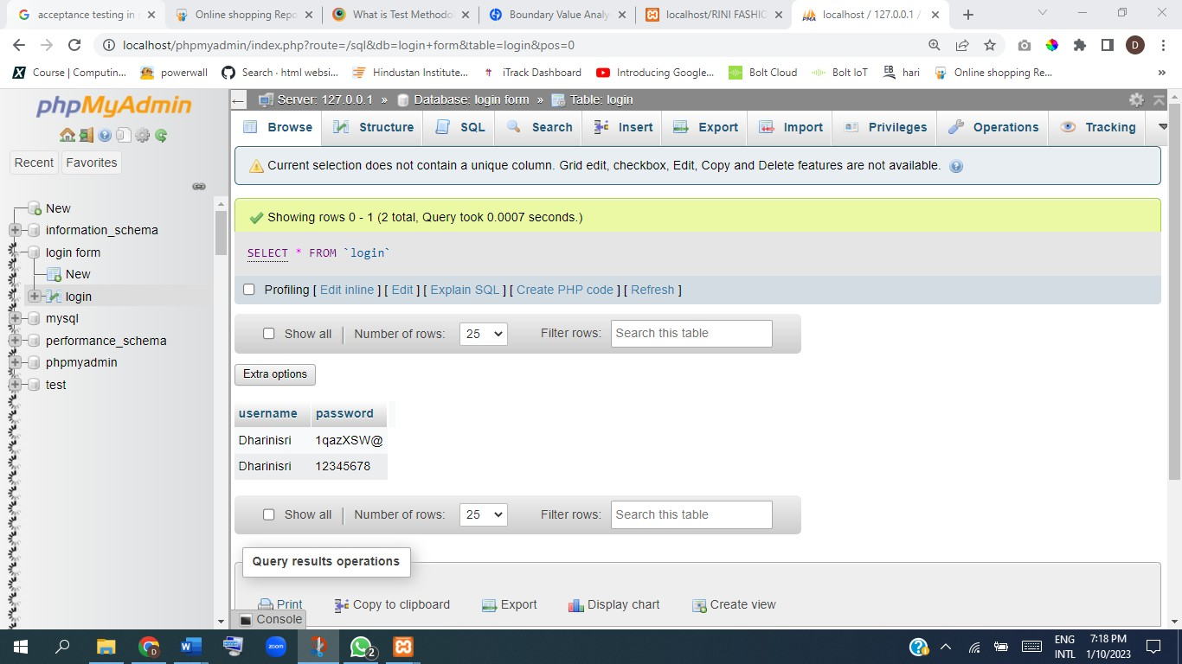

1. **SYSTEM TESTING:**

**TYPE OF TESTING:**

The aim of the system testing process was to determine all defects in our project .The PROGRAM was subjected to a set of test inputs and various observations were made and based on these observations it will be decided whether the program behaves as expected or not.

Our Project went through levels of testing

UNIT TESTING:

Each module is consider which model is consider independently it focus on each unit of software is implemented in the source code it is while box testing.

INTEGRATION TESTING**:**

Integration testing at testing the program structure while at the same structuring text to uncover error associated with interfacing the module ticketed by using the top down approach.

VALIDATION TESTING:

Validation testing was performed to ensure that all the functional and performance requirements are met.

SYSTEM TESTING:

system testing it is executed program to check logical change made with the intention of finding error the system status for online response volume trisection recovery and federal system testing is done to ensure that the system statistic all the user requirement

TECHNICAL DESIGN:

The activity built upon pacification procedure to ring new system design adding detail technical specification and documentation.

TEST SPECIFICATION AND PLANNING

Test specification and planning activity prepare detailed test specification for individual module and program job system and for the system as a whole.

PROGRAMMING AND TESTING:

This activity encompasses actual development, writing and testing program units or modules.

USER TRAINING:

This activity encompasses writing user procedure manuals preparation of user training materials, conducting training program and testing procedures.

ACCEPTANCE TEST:

A final procedural review to demonstrate a system and secure user approval before a system become operational.

INSTALLATION PHASE:

In this phase the new computerized system is installed, the conversion to new procedure is fully implemented and the potential of the new system is explored.

**TEST METHODOLOGY:**

**Testing Methodologies**:  
Software Testing methodologies are the approaches and strategies used for testing a precise  
product to make sure it is fit for purpose. It generally entails testing that the product functions  
along with its specification, has no unwanted side effects when used in modes outside of its design  
parameters, and the most horrible case, will fail safely.

Some well-accepted testing methodologies comprise –  
1.Waterfall Model :  
It is a linear, sequential approach to the software development lifecycle (SDLC) that is  
popular in software engineering and product development.  
2. Agile Methodology :  
It aligns with iterative development methodology in which requirements develop gradually  
from customers and testing teams.  
3. Iterative Model :  
A subset of the final product under development, which grows from iteration to iteration  
to become the final product or software.  
4.V-Model :  
It is an SDLC model where execution of processes happens in a sequential manner in a V-  
shape. It is also known as Verification and Validation model.  
5.Spiral Model :  
It is a systems development lifecycle (SDLC) method used for risk management that  
combines the iterative development process model with elements of the Waterfall model.  
6.Extreme Programming Model :  
It is an agile software development framework that aims to produce higher quality  
software, and higher quality of life for the development team.  
7.RAD (Rapid Action Development) Model :  
It is a software development process based on prototyping without any specific planning.  
In model, there is less attention paid to the planning and more priority is given to the development  
tasks. It targets at developing software in a short span of time.

**Boundary Value Analysis and Equivalence Partitioning:**

Practically, due to time and budget considerations, it is not possible to perform exhausting testing for each set of test data, especially when there is a large pool of input combinations.

We need an easy way or special techniques that can select test cases intelligently from the pool of test- case, such that all test scenarios are covered. We use two techniques – Equivalence Partitioning &

Boundary Value Analysis testing techniques to achieve this. Boundary testing is the process of testing between extreme ends or boundaries between partitions of the input values.

* So, these extreme ends like Start- End, Lower- Upper, Maximum-Minimum, Just Inside-Just Outside values are called boundary values and the testing is called “boundary testing”.
* The basic idea in normal boundary value testing is to select input variable values at their:

1. Minimum
2. Just above the minimum
3. A nominal value
4. Just below the maximum
5. Maximum
   1. **est Report**

**Test cases for BALAJI fruit company website:**

**Project name**: BALAJI Fruit Company

**Reference**: Google Website You Tube

**Created by**: kamal Dukare

**On date**: 11-01-2023

**Return date**: 14-01-2023

**Test scenario: 001 login**

|  |  |  |  |  |  |  |  |  |
| --- | --- | --- | --- | --- | --- | --- | --- | --- |
| **Test case ID** | **Test case Description** | **Precondition** | **Steps** | **Input Data** | **Expect**  **ed Result** | **Actual Result** | **Post condition** | **Result** |
| TC-001 | Verify login functionality with the valid Email id | 1.Internet connection should be present 2.user should have account | 1.open login page 2.enter valid Email-id | Er.kamal2022 @gmail  .com | User should be able to enter the Email-  id | Same as expected | Successful ly Entered Email-id | Pass |
| TC-002 | Verify login functionality with the valid password | 1. Internet connection should be present 2. user should have account 3.user should enter the   email id | 1.open login page 2.enter valid Email-id 3.Enter the password | monika @1234 | User should be able to enter the passwo rd | Same as expected | Successful ly Entered Password | Pass |

**Test scenario: 002 Product**

|  |  |  |  |  |  |  |  |  |
| --- | --- | --- | --- | --- | --- | --- | --- | --- |
| **Test case ID** | **Test case Description** | **Precondition** | **Steps** | **Input Data** | **Expected Result** | **Actual Result** | **Post**  **conditio n** | **Result** |
| TC-001 | Checking the products functionality | 1.Internet connection should be present 2.user s hould have account | 1.open login page 2.enter valid Email-id 3.enter password 4.Click on Products functionali  ty | N/A | User should be able to  click on Products functionali ty | Same as expecte d | Successf ully opened the Products page | Pass |

|  |  |  |  |  |  |  |  |  |
| --- | --- | --- | --- | --- | --- | --- | --- | --- |
| **Test case ID** | **Test case Description** | **Precondition** | **Steps** | **Input Data** | **Expected Result** | **Actual Result** | **Post**  **conditio n** | **Result** |
| TC-001 | Checking the category functionality | 1.Internet connection should be present 2.user should have account | 1.open login page 2.enter valid Email-id 3.enter password 4.Click on category functionali  ty | N/A | User should be able to  click on category functionali ty | Same as expecte d | Successf ully opened the category page | Pass |

**Test scenario: 003 categories**

## Selenium Code for Amazon Website:

import org.openqa.selenium.WebDriver;

importorg.openqa.selenium.chrome.ChromeDriver; import org.openqa.selenium.support.ui.Select;

public class Amazon {

public static void main(String[] args) throws InterruptedException

{

System.setProperty("Webdriver.chrome.driver",

## "C:\\Users\\abc\\Desktop\\chromedriver_win32\\chromedriver.exe");

WebDriver driver=new ChromeDriver();

driver.get[("http](http://www.amazon.in/):[//w](http://www.amazon.in/)w[w.amazon.in/");](http://www.amazon.in/)//Open Amazon driver.manage().window().maximize(); System.out.println(driver.getTitle());

driver.findElement(By.xpath("//*[@id=\"twotabsearchtextbox\"]")).sendKeys("Mobile"); driver.findElement(By.xpath("//*[@id=\"nav-search-submit-button\"]")).click(); Thread.sleep(1000);

driver.findElement(By.linkText("EN")).click();

Thread.sleep(1000);

driver.findElement(By.className("a-button-text")).click(); //cancel Thread.sleep(1000);

driver.findElement(By.cssSelector("#nav-link-accountList ")).click(); //Sign-in Thread.sleep(1000); driver.findElement(By.id("ap_email")).sendKeys("[er.kamal@gmail.com](mailto:er.kamal@gmail.com)"); Thread.sleep(1000);

driver.findElement(By.id("continue")).click(); Thread.sleep(1000); driver.findElement(By.cssSelector("#continue")).click(); Thread.sleep(1000); driver.findElement(By.id("createAccountSubmit")).click(); Thread.sleep(1000);

driver.findElement(By.className("a-input-text")).sendKeys("kavya"); Thread.sleep(1000); driver.findElement(By.id("ap_phone_number")).sendKeys("8080423027");

driver.findElement(By.name("secondaryLoginClaim")).sendKeys[("e](mailto:er.mohinichavan@gmail.com)r.[kamal@gmail.com](mailto:kamal@gmail.com)");

driver.findElement(By.id("ap_password")).sendKeys("abc@1234"); driver.findElement(By.className("a-button-input")).click();

**//Navigate to facebook sign up page** driver.navigate().to("https://[www.facebook.com/campaign/landing.php?campaign_id=14884913640&ext](http://www.facebook.com/campaign/landing.php?campaign_id=14884913640&ext) ra_1=s%7Cc%7C589460569870%7Cb%7Cfb%20create%20account%7C&placement=&creative=58946 0569870&keyword=fb%20create%20account&partner_id=googlesem&extra_2=campaignid%3D148849 13640%26adgroupid%3D128696221432%26matchtype%3Db%26network%3Dg%26source%3Dnotmob ile%26search_or_content%3Ds%26device%3Dc%26devicemodel%3D%26adposition%3D%26target%3 D%26targetid%3Dkwd- 332264388364%26loc_physical_ms%3D1007786%26loc_interest_ms%3D%26feeditemid%3D%26para m1%3D%26param2%3D&gclid=Cj0KCQiA14WdBhD8ARIsANao07gCwXFda4ohrrPZF6UHfiSK6C_ zOeWVyC3DwkA7VfLvWh0x05IQeGoaAoy6EALw_wcB"); driver.findElement(By.name("firstname")).sendKeys("kamal"); driver.findElement(By.name("lastname")).sendKeys("dukare"); driver.findElement(By.name("reg_email ")).sendKeys("8080423027"); driver.findElement(By.name("reg_passwd ")).sendKeys("abc@123");

**//Dropdown list**

Select se = new Select(driver.findElement(By.xpath("//*[@id=\"day\"]"))); se.selectByValue("7");

Select se1 = new Select(driver.findElement(By.xpath("//*[@id=\"month\"]"))); se1.selectByVisibleText("May");

Select seYr = new Select(driver.findElement(By.id("year"))); seYr.selectByIndex(25); driver.findElement(By.name("sex")).click();//for selecting female driver.findElement(By.name("websubmit")).click();

driver.quit();

}

}

**//Drag and Drop Code**

package Selenium_code;

import org.openqa.selenium.By;

import org.openqa.selenium.WebDriver; import org.openqa.selenium.WebElement;import org.openqa.selenium.chrome.ChromeDriver; import org.openqa.selenium.interactions.Actions;

public class DragAndDrop {

public static void main(String[] args) throws InterruptedException {

//Set the path of executable Browser Driver System.setProperty("Webdriver.chrome.driver",

"C:\\Users\\abc\Desktop\\chromedriver_win32\\chromedriver.exe");

WebDriver driver=new ChromeDriver(); //Parent p=new Child (webdriver is Parent & ChromeDriver is Child)

driver.manage().window().maximize(); driver.get("https://jqueryui.com/droppable/");

//WebElement iframe = driver.findElement(By.tagName("iframe"));

WebElement iframe = driver.findElement(By.xpath("//*[@id=\"content\"]/iframe")); driver.switchTo().frame(iframe);

WebElement draggableitem=driver.findElement(By.id("draggable")); WebElement droppableitem=driver.findElement(By.id("droppable")); Thread.sleep(2000);

Actions action = new Actions(driver); action.dragAndDrop(draggableitem, droppableitem).build().perform();}}

## CONCLUSION:

## In conclusion, there are many benefits to consuming fruits and daily. We know from the healthy plate example, that fruits and will not supply us with everything our body needs but it does make up a good portion of it. Hopefully this web quest provided you with plenty of information that will encourage not just to eat more fruits and vegetables but to living a healthy lifestyle and eating a healthy diet that includes all food groups.

**Reference:**

[DG Health and Food Safety website, European Core Health Indicators (ECHI)](http://ec.europa.eu/health/dyna/echi/datatool/index.cfm?indlist=50) (accessed 10/10/2016)

[DGA(2015) Dietary Guidelines for Americans, U.S. Department of Health and Human Services and U.S. Department of Agriculture. 2015–2020 Dietary Guidelines for Americans.](http://health.gov/dietaryguidelines/2015/)

[DGAC (2015), Dietary Guidelines Advisory Committee, Scientific Report](http://health.gov/dietaryguidelines/2015-scientific-report/07-chapter-2/d2-3.asp)

[DGE (2012) German Nutrition Sociery critical review Eur J Nutr (2012); 51(6)637-663](https://www.ncbi.nlm.nih.gov/pmc/articles/PMC3419346/pdf/394_2012_Article_380.pdf)

[DGE (2013),10 guidelines of the German Nutrition Society (DGE) for a wholesome diet](https://www.dge.de/index.php?id=322)

[DGE (2016) German Nutrition Sociery Nutrition report](https://www.dge.de/wissenschaft/ernaehrungsberichte/13-dge-ernaehrungsbericht/) (accessed 22/08/2017)

[EFSA Comprehensive European Food Consumption database.](https://www.efsa.europa.eu/en/food-consumption/comprehensive-database) (last accessed 21/07/2016)

[ENHR (2009) European Nutrition and Health Report, Elmadfa I. Forum of Nutrition 62, 1-412](http://dx.doi.org/10.1159/000242367)

[EU (2014) EU Action Plan on Childhood Obesity (2014)](http://ec.europa.eu/health/nutrition_physical_activity/docs/childhoodobesity_actionplan_2014_2020_en.pdf)

[Eurostat, European Union Statistics. News release 14/10/2016](http://ec.europa.eu/eurostat/documents/2995521/7694616/3-14102016-BP-EN.pdf/1234ac94-27fd-4640-b9be-427a42d54881)

[Finnish Food Safety Authority website (2017)](https://www.evira.fi/en/foodstuff/healthy-diet/nutrition-recommendations-for-all/adults2/) (accessed 10/10/2017)

[GBD Study (2017) Global Burden of Disease Study, Global, regional, and national comparative](http://www.healthdata.org/research-article/global-regional-and-national-comparative-risk-assessment-84-behavioral-0)